**Project Design Phase-II**

**Technology Stack (Architecture & Stack)**

|  |  |
| --- | --- |
| Date | 10 November 2022 |
| Team ID | PNT2022TMID23390 |
| Project Name | University Admit Eligibility Predictor |
| Maximum Marks | 4 Marks |

**Technical Architecture:**

The Deliverable shall include the architectural diagram as below and the information as per the table1 & table 2

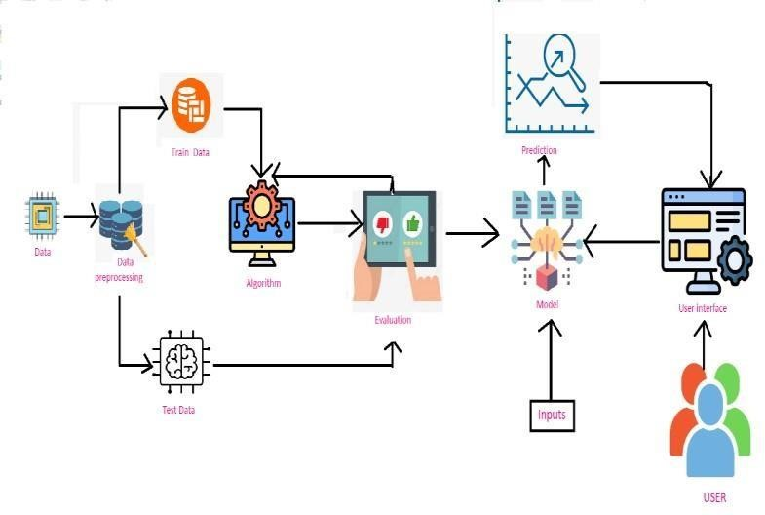

1.

Include all

the processes

(

As

an

application

logic

/

Technology

Block)

2.

3.

4.

5.

Provide

infrastructural

demarcation

(

Local

/

Cloud)

Indicate external

interfaces

(

third

party

API’s

etc.)

Indicate Data Storage components / services

Indicate

interface

to

machine

learning

models

(

if

applicable)

Guidelines:

|  |  |  |  |
| --- | --- | --- | --- |
| **S.No** | **Characteristics** | **Description** | **Technology** |
| 1. | Open-Source Frameworks | List the open-source frameworks used | Technology of Open source framework |
| 2. | Security Implementations | List all the security / access controls implemented, use of firewalls etc. | e.g. SHA-256, Encryptions, IAM Controls, OWASP etc. |
| 3. | Scalable Architecture | Justify the scalability of architecture (3 – tier, Micro- services) | Technology used |
| 4. | Availability | Justify the availability of application (e.g. use of load balancers, distributed servers etc.) | Technology used |

**Table-1 : Components & Technologies:**

|  |  |  |  |
| --- | --- | --- | --- |
| **S.No** | **Component** | **Description** | **Technology** |
| 1. | User Interface | The user interacts with application through the UI | HTML, CSS, JavaScript. |
| 2. | Application Logic-1 | Logic for collecting the input from the user. | Python |
| 3. | Application Logic-2 | Integrating machine learning model with our application. | Python |
| 4. | Database | Numeric data. | MySQL. |
| 5. | File Storage | To store file such as prediction report. | Local Filesystem |
| 6. | Machine learning model | Predictive modelling is a mathematical process used to predict future events or outcomes. | Regression modelling |
| 7. | Infrastructure (server /cloud) | Application Deployment on Local System Local Server Configuration : Built in flask web server. | Flask, web server |

**Table-2: Application Characteristics:**

|  |  |  |  |
| --- | --- | --- | --- |
| 5. | Performance | Design consideration for the performance of the application (number of requests per sec, use of Cache, use of CDN’s) etc. | Technology used |